Declan Sheehan

Dr. Anderson

COSC320-001

13, November 2019

Lab 9 README

Approach:
My approach to this lab is generalized by the following:
- Followed the pseudocode
- Repurposed Lab 8 functions
- Kept in mind the attributes of a red black tree
- Used newer commands to find deallocation issues, such as:
  - Valgrind --leak-check=full -v ./lab9.exe

Theoretic Time Complexity:
Averages:

RBT BST
Insert: O(logn) O(logn)
Delete: O(logn) O(logn)
Search: O(logn) O(logn)

For Binary Search Tree, worst case is O(n) for above functions.
For Red Black Tree, worst case is O(logn) for above functions.
Red Black Tree VS Binary Search Tree Operations:
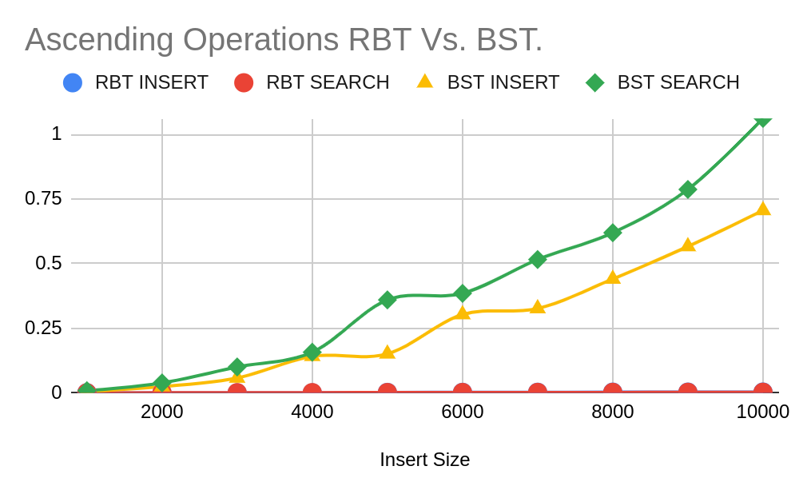
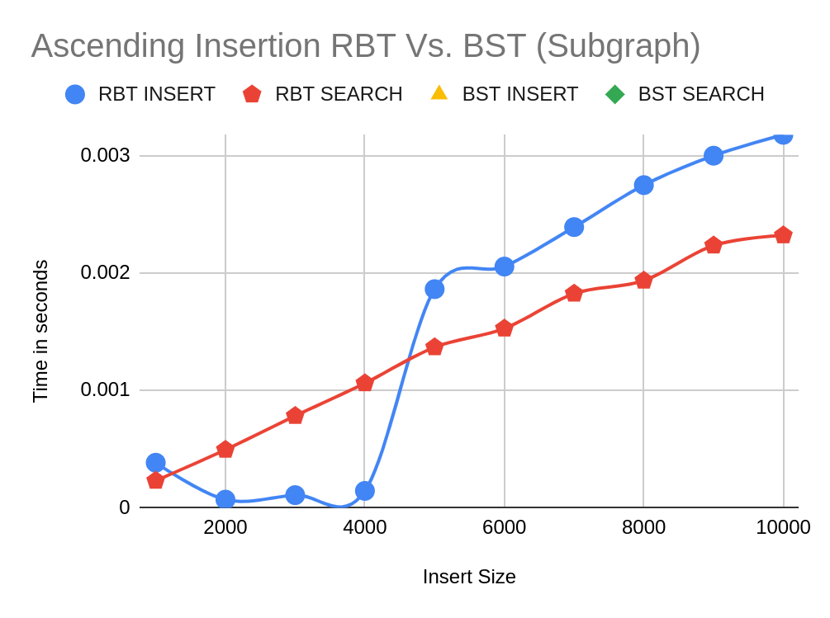
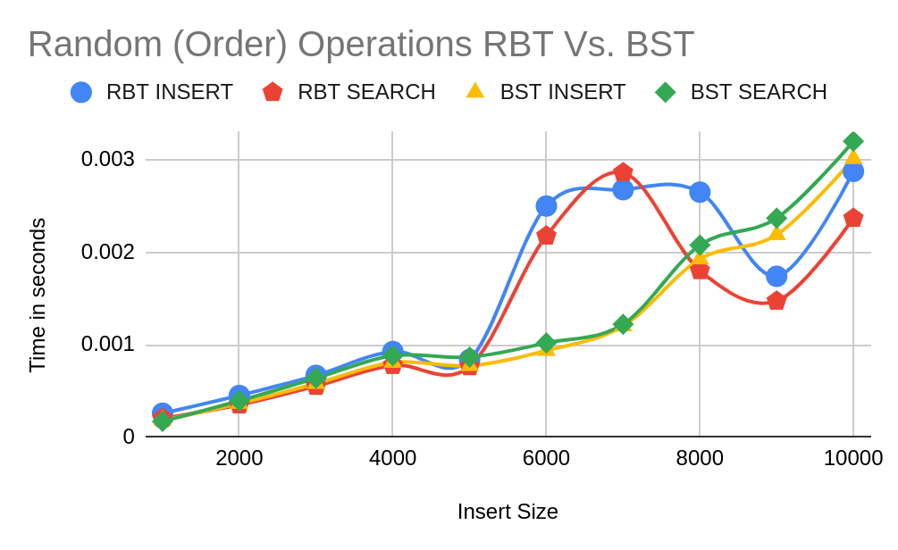
Judging from the above graphs collected from the tests, RBT will eventually out-perform a regular BST in insertion and search operations. If we are to believe the worst case for BST is O(n), we can see that RBT takes a fair bit less, so O(logn) for RBT makes total sense for its time complexity.
Data Tables:

Insert Size | RBT INSERT | RBT SEARCH | BST INSERT | BST SEARCH
1000 | 0.000384389 | 0.000231568 | 0.00549893 | 0.0084586
2000 | 0.000070397 | 0.000495383 | 0.0241955 | 0.0384736
3000 | 0.000108592 | 0.000783538 | 0.0576503 | 0.100328
4000 | 0.000144699 | 0.00106156 | 0.141716 | 0.157475
5000 | 0.00186244 | 0.00136826 | 0.151194 | 0.359782
6000 | 0.00205467 | 0.00152749 | 0.303314 | 0.385109
7000 | 0.0023909 | 0.00182485 | 0.326561 | 0.5162
8000 | 0.00274822 | 0.00193544 | 0.440721 | 0.619663
9000 | 0.00299866 | 0.00223464 | 0.566646 | 0.787337
10000 | 0.00317657 | 0.00232102 | 0.706213 | 1.06223

Insert Size | RBT INSERT | RBT SEARCH | BST INSERT | BST SEARCH
1000 | 0.000258462 | 0.000202854 | 0.000181126 | 0.000170359
2000 | 0.000450867 | 0.00034974 | 0.000364075 | 0.000393397
3000 | 0.000668398 | 0.000551248 | 0.000579088 | 0.000638229
4000 | 0.00092589 | 0.000776875 | 0.000808295 | 0.000881815
5000 | 0.000838566 | 0.000763377 | 0.000772824 | 0.000865728
6000 | 0.00250037 | 0.00217726 | 0.000936566 | 0.00101951
7000 | 0.00267785 | 0.00286211 | 0.00120203 | 0.00122144
8000 | 0.0026508 | 0.00180341 | 0.00192724 | 0.00207773
9000 | 0.00174013 | 0.00147215 | 0.00219 | 0.00236958
10000 | 0.00287576 | 0.00236873 | 0.0030122 | 0.00320115

Code Improvements:
Even though the delete node works, It stills seg-faults when testing the delete function for > 1000 elements. It is either that or it leaks data; I can’t remember. Fixing that would be “good”.

